1. 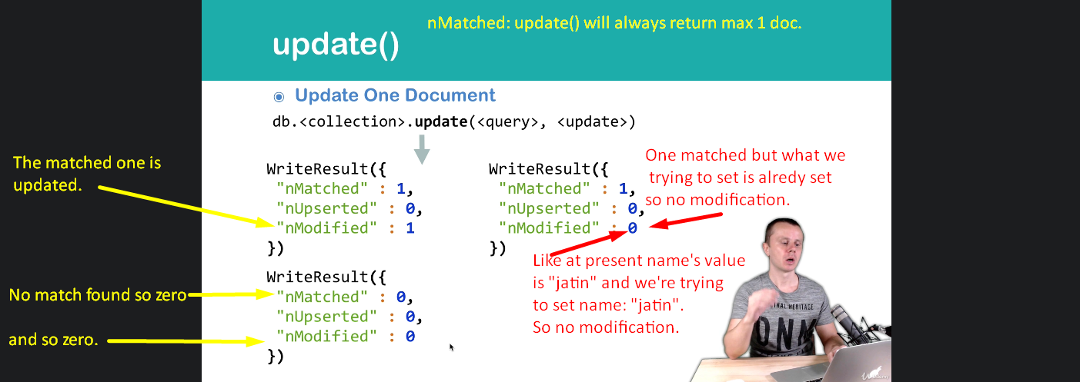
2. Let’s verify the above WriteResult({}) in console as GUI interprets the WriteResult and display the result in user-friendly way.
3. 